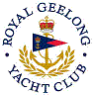 | Royal Geelong Yacht Club Inc.  Est 1859
Trophy Deed of Gift.

Trophy: | Searle Bros. Perpetual Cup
Presented by: | Tal and Jim Searle
Date: | 1951
For: | Cadet Class: Winner of Handicap
Remarks / Revisions | Allocated to Blue Division when Fleet split into Red/Blue
Click here for a List of Recipients

In 1949-50, the Searle Brothers instigated the beginning of the very successful Yachting World Cadet Dinghies in Australia.
A committee was formed comprising Jim (Secretary), brother Tal (official measurer), the Commodore (Lance Curtis), Allan Taylor, Johnny O'Brien, Stan Jewell, Ern Armstrong and Captain Hancock.
Jim built the prototype "Vanguard" in the backyard of the mixed business in Hope Street, West Geelong. The prototype was used by J.C. Taylor to prefabricate 30 odd "build yourself" kits which were sold for £38.00.
Issy Prior (Prior Sails, St Kilda) was contracted to supply the sails at a cut rate.

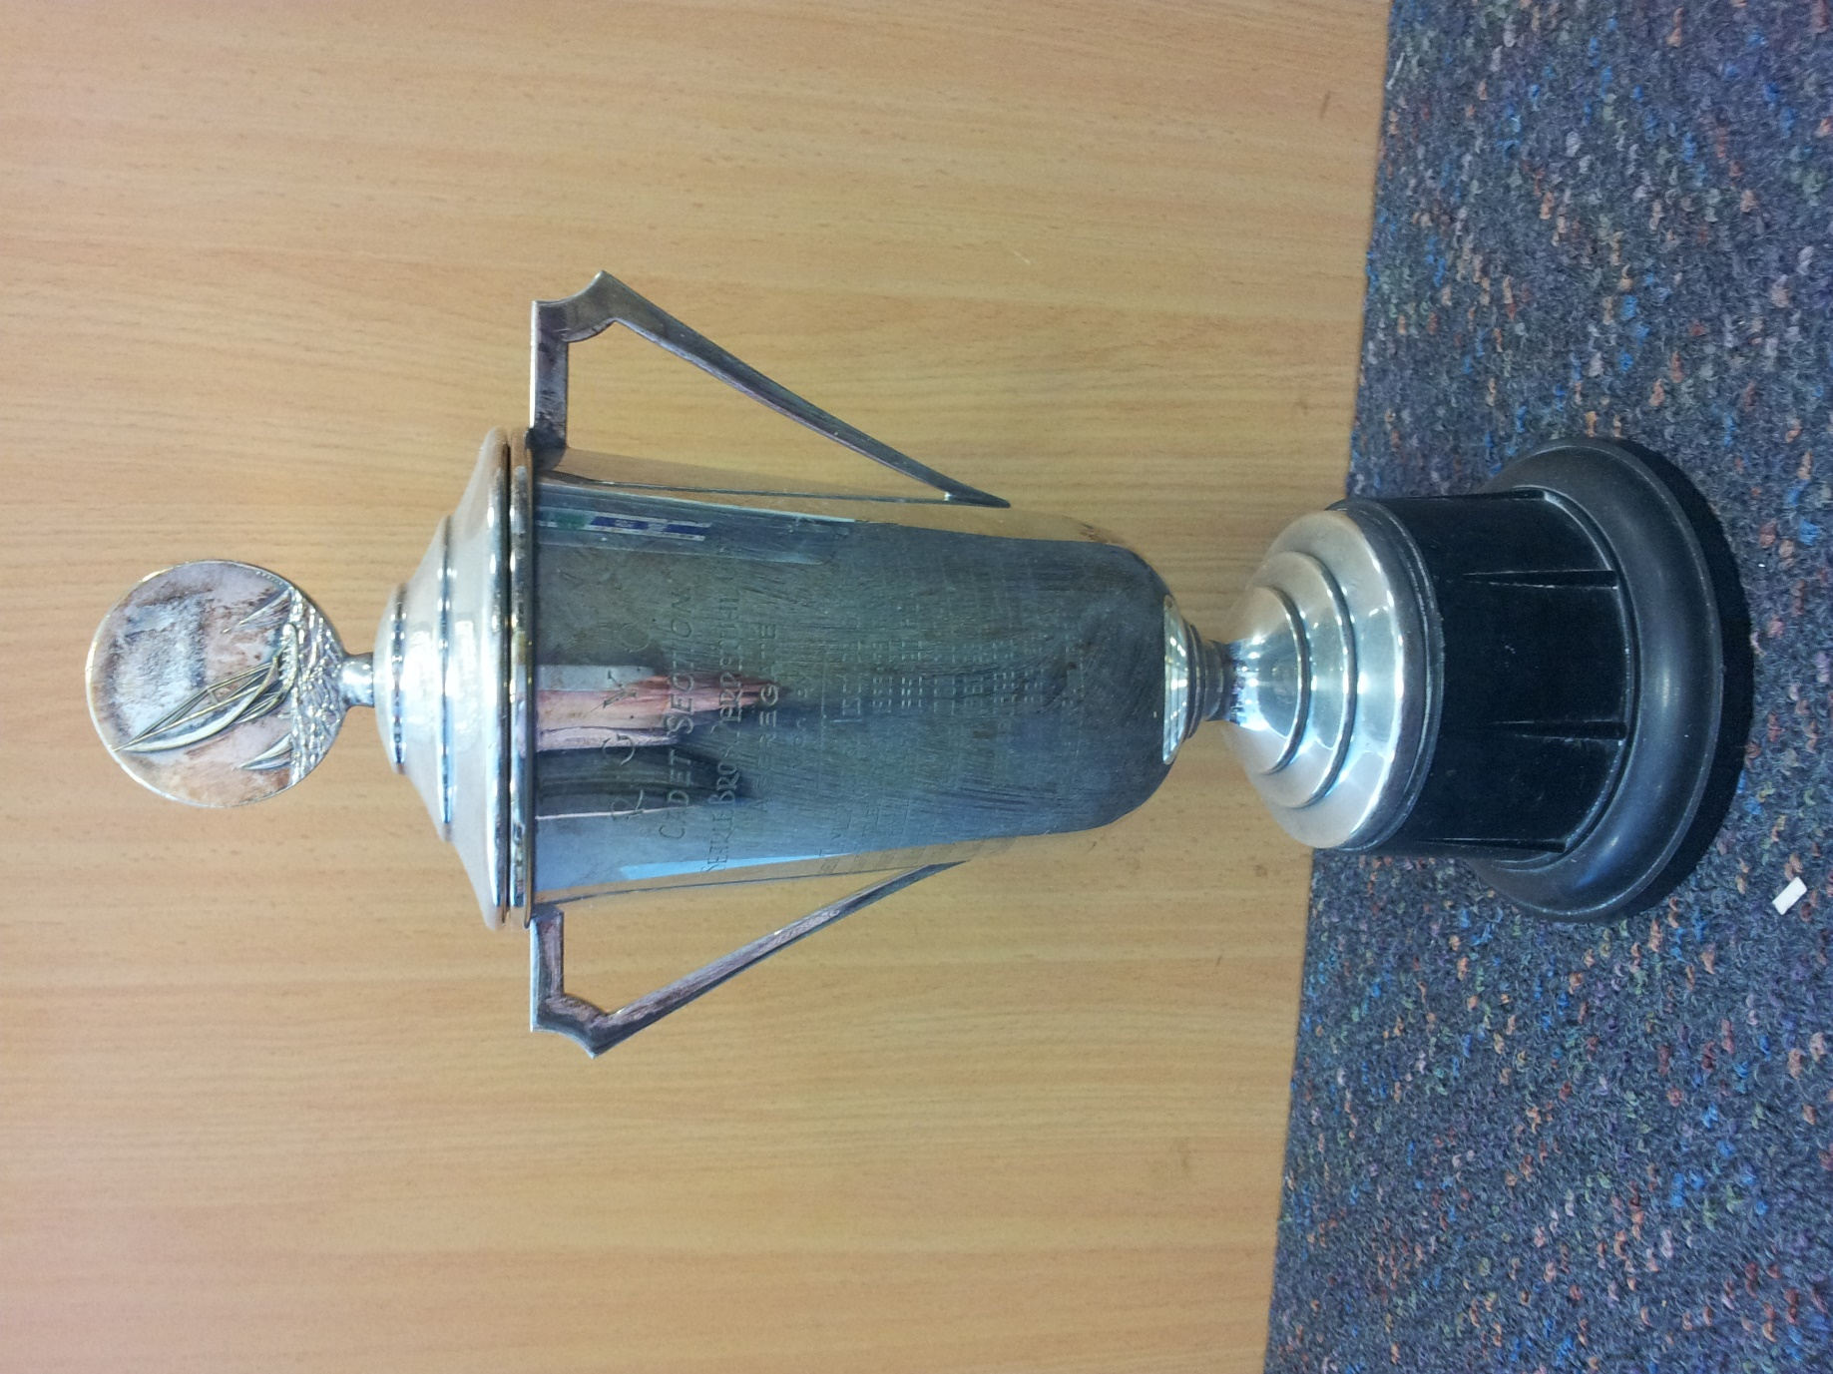

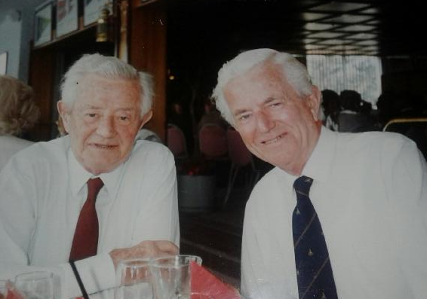
James B. (Jim) Searle | Tal Searle

